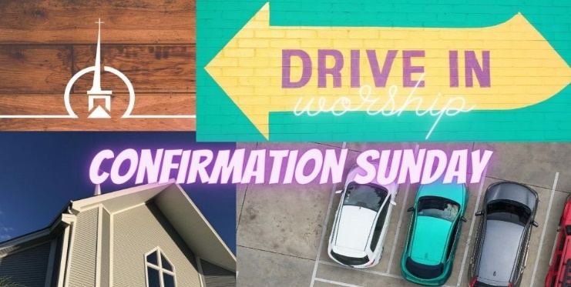
“Build My Life”

Verse 1
Worthy of ev'ry song we could ever sing
Worthy of all the praise we could ever bring
Worthy of ev'ry breath we could ever breathe
We live for You

Verse 2
Jesus the name above ev'ry other name
Jesus the only one who could ever save
Worthy of ev'ry breath we could ever breathe
We live for You, We live for You

Chorus
Holy there is no one like You
There is none beside You
Open up my eyes in wonder and show me who You are
And fill me with Your heart
And lead me in Your love to those around me

Bridge
I will build my life upon Your love
It is a firm foundation
I will put my trust in You alone
And I will not be shaken

Chorus

“I Was There to Hear Your Borning Cry”

I was there to hear your borning cry,
I'll be there when you are old.
I rejoiced the day you were baptized,
To see your life unfold.
I was there when you were but a child,
With a faith to suit you well;
In a blaze of light you wandered off
To find where demons dwell.
Attica Kenning
When you heard the wonder of the Word
I was there to cheer you on;
You were raised to praise the living God,
To whom you now belong.
If you find someone to share your time
And you join your hearts as one,

I'll be there to make your verses rhyme
From dusk 'till rising sun.
Sunday, September 27, 2020
FM Station: 90.5
In the middle ages of your life,
Not too old, no longer young,
I'll be there to guide you through the night,
Complete what I've begun.
When the evening gently closes in,
And you shut your weary eyes,
I'll be there as I have always been
With just one more surprise.

I was there to hear your borning cry,
I'll be there when you are old.
I rejoiced the day you were baptized,
To see your life unfold.

“Forever On Your Side”

I won't pretend
That we can control the night
Or what kind of road we're on
Or where we will see the light
But right now I'm talking to you
I'm lookin' into your eyes
Right now I'm tryin' to show you
That we're gonna be alright

Pre-Chorus
Oh, I don't know what's around the bend
All I know is that my love, it knows no end

Chorus
All these pieces, they fall in line
Because I'm forever on your side
Take my hand when you can't see the light
'Cause I'm forever on your side
I will carry you every time
'Cause I'm forever on your side

Verse 2
They'll beat you up
But don't let 'em keep you down
'Cause you're always tough enough
And I'll always be around

Pre-Chorus

Chorus

Bridge
Oh, I can't promise that a day will never come
Where the ground beneath us falls out and we got nowhere to run
Oh, but you won't be alone when the waters start to rise up
No, you won't be alone my darling when the rains come

Pre-Chorus

Chorus
Oh, I'm forever on your side (x3)

