“O For a Thousand Tongues to Sing”

Verse 1
O for a thousand tongues to sing
My great Redeemer’s praise,
The glories of my God and King,
The triumphs of his grace!

Verse 2
My gracious Master and my God,
Assist me to proclaim,
To speak thro’ all the earth abroad
The honors of your name.

Verse 3
Jesus! the name that charms our fears,
That bids our sorrows cease,
‘Tis music in the sinner’s ears,
‘Tis life and health and peace.

Verse 5
To God all glory, praise and love
Be now and ever given
By saints below and saints above,
The Church in earth and heaven.

“If We're Honest”

Verse 1
Truth is harder than a lie
The dark seems safer than the light
And everyone has a heart that loves to hide

Verse 2
I'm a mess and so are you
We've built walls nobody can get through
Yeah it may be hard
But the best thing we could ever do ever do

Chorus
(So) Bring your brokenness and I'll bring mine
'Cause love can heal what hurt divides
And mercy's waiting on the other side
If we're honest if we're honest

Verse 3
Sunday, October 4, 2020
FM Station: 90.5
Don't pretend to be something that you're not
Living life afraid of getting caught
There is freedom found
When we lay our secrets down at the cross
At the cross

Chorus

Bridge
It would change our lives
It would set us free
It's what we need to be

Chorus

CCLI Song # 7006197
Francesca Battistelli | Jeff Pardo | Molly Reed
© Da Bears Da Bears Da Bears Music (Admin. by Capitol CMG Publishing)
Meaux Jeaux Music (Admin. by Capitol CMG Publishing)
Curb Word Music (Admin. by WB Music Corp.)
Francesca Music (Admin. by Word Entertainment, LLC)
Goes Something Like This Music (Admin. by Word Entertainment, LLC)
Warner-Tamerlane Publishing Corp. (Admin. by Word Entertainment, LLC)
For use solely with the SongSelect®. Terms of Use. All rights reserved. www.ccli.com
CCLI License # 609060

“One Bread, One Body”

Chorus
One bread, one body, one Lord of all
One cup of blessing which we bless
And we, though many, throughout the earth
We are one body in this one Lord

Verse 1
Gentile or Jew
Servant or free
Woman or man
No more

Chorus

Verse 2
Many the gifts,
Many the works
One in the Lord
Of all

Chorus

“Lean On Me”

Verse 1
Sometimes in our lives we all have pain
We all have sorrow
But if we are wise
We know that there's always tomorrow

Chorus
Lean on me, when you're not strong
And I'll be your friend
I'll help you carry on
For it won't be long
'Til I'm gonna need
Somebody to lean on

Verse 2
Please swallow your pride
If I have things you need to borrow
For no one can fill those of your needs
That you won't let show

Bridge
You just call on me brother, when you need a hand
We all need somebody to lean on
I just might have a problem that you'll understand
We all need somebody to lean on

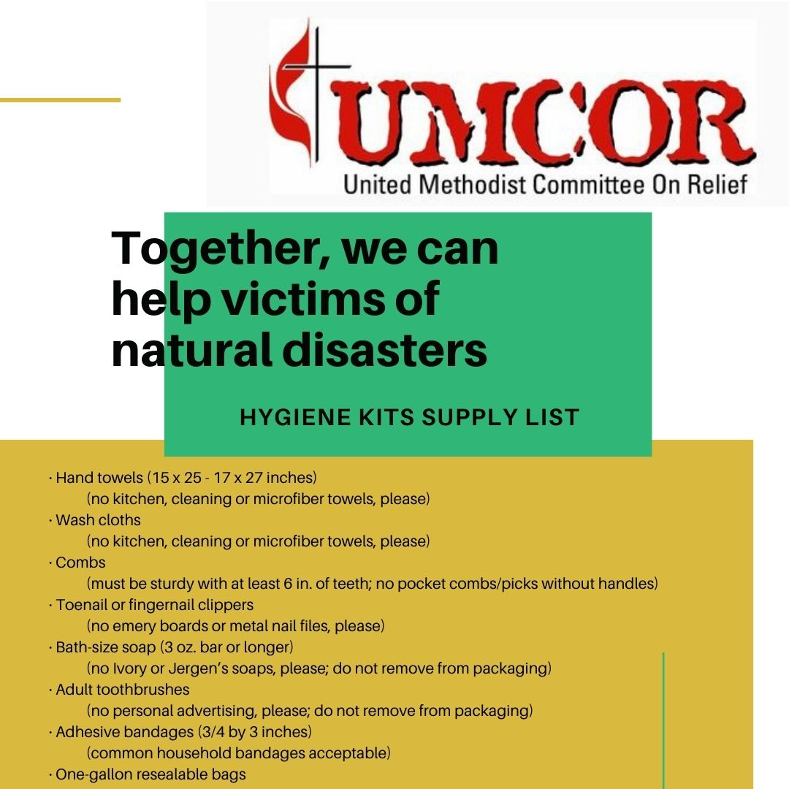
Chorus

Bridge

Verse 3
If there is a load you have to bear
That you can't carry
I'm right up the road
I'll share your load
If you just call me (call me)
Tag
If you need a friend, call me (repeat)

Please bring in donations for victims of the recent hurricanes and wildfires. Donations will be received at next week’s drive-in worship service. They can also be dropped off mid-week
(but please call the office first to let Joanie know you’re coming!).

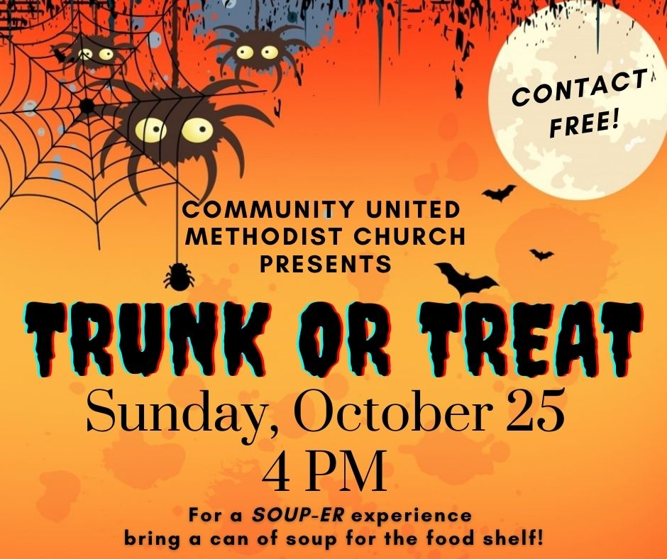

Please help us reach out to our larger community by decorating your trunk and handing out candy!
To Sign up: contact Joanie in the church office.
The person/household with the most creative method for contact-free candy distribution wins a dozen cupcakes from Judy Hanson!

